**Experimental Details:**

**Introduction**

ZnO thin films have been deposited by spin coating fabrication technique. Spin coating is a widely used deposition technique for creating thin films on a substrate. It is a simple and effective method that involves applying a liquid solution or suspension onto a substrate, which is then spun at high speeds to spread the material uniformly. However, it has the drawback of making large area samples difficult. The desired film thickness can be obtained using the spin-coating technique. Spin coating technique is very simple and cost effective. The spin coater we used in our laboratory is shown in following figure 3…….

Number of rotations and time for the rotation is set up before dropping the solution. The volume of solution, drop technique etc. are controlled manually. Zinc acetate, 2methoxyethanol, mono-ethanolamine were used to deposit pure ZnO thin film. Here we created two types of films, one is pure ZnO thin film, and others are 1%, 3%, and 5% Y (Yttrium) doped ZnO thin films.

**Film Synthesis**

**Raw Materials:**

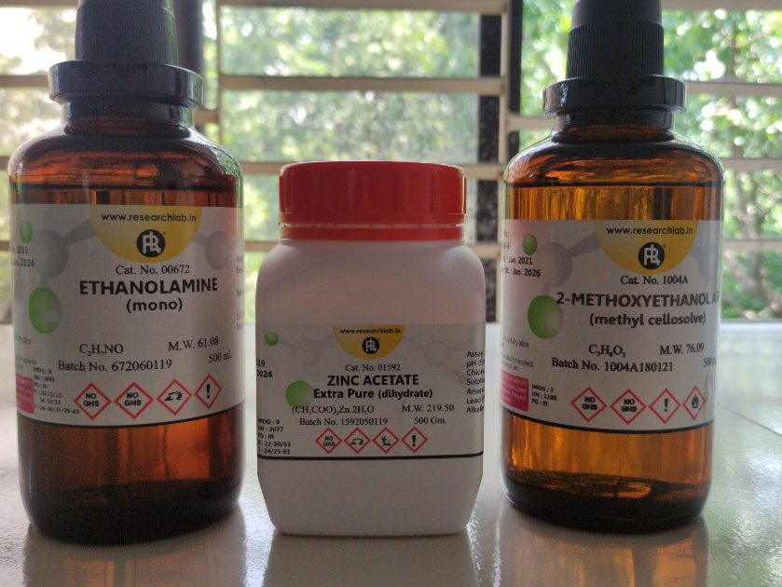

**Fig:** Raw chemical reagents

* **Starting Materials:**
* Zinc acetate dehydrate (ZAD)[𝑍𝑛 (𝐶𝐻3𝐶𝑂𝑂𝐻)2.2𝐻2O]
* Molecular weight 219.49 gm/mol



**Figure 3.1**: Starting Material (Zinc Acetate Dehydrate)

* **Solvent**
* 2-methoxy ethanol (MOE) (𝐶𝐻3𝑂𝐶𝐻2𝐶𝐻2OH)
* **Stabilizer**
* Mono-ethanol-amine (MEA) [(𝐻𝑂𝐶𝐻2𝐶𝐻2)𝑁𝐻2]
* Molecular weight 61.08 gm/mol
* Density 1.015 gm/cc



**Figure:** Solvent and Stabilizer (2-methoxy ethanol & Mono-ethanol-amine)

**Doping Material**

* **Yttrium Nitrate Hexahydrate (**Y(NO3)3·6H2O)
* Molecular weight 383.01 g/mol

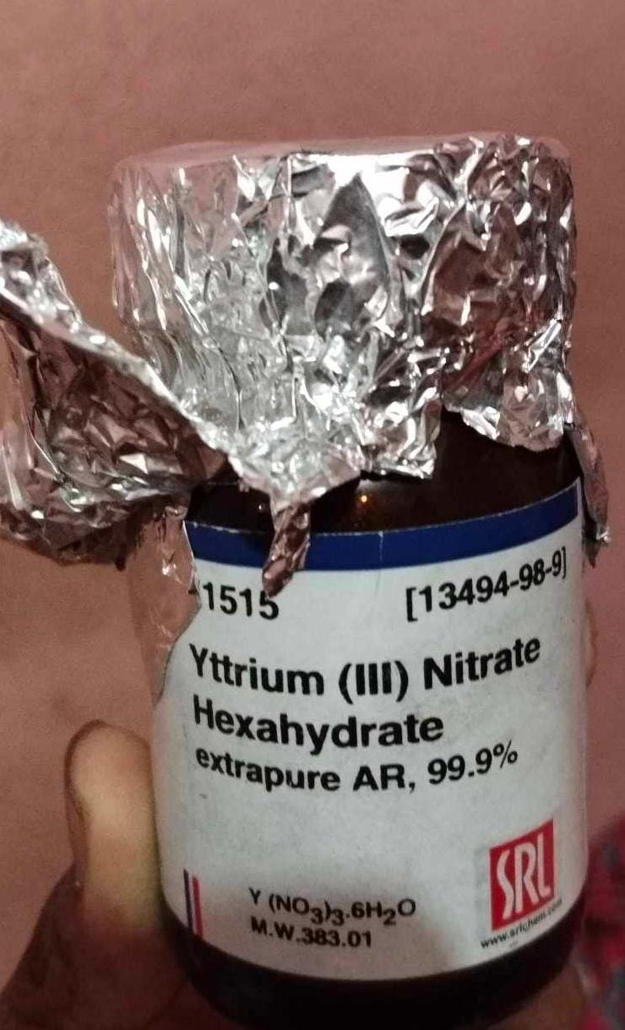

**Figure:** Doping material (Yttrium)

**Other ingredients**

* Glass (75mm*25mm*1mm)
* Glass cutter
* Washing agent:
* Acetone
* Ethanol
* De-ionized water
* Beaker (200 ml-2 ,500 ml -1)
* Magnetic stirrer
* Hot plate
* Ultrasonic cleaner
* Thermometer
* Micro-pipet
* Others





**(b)**

**(a)**

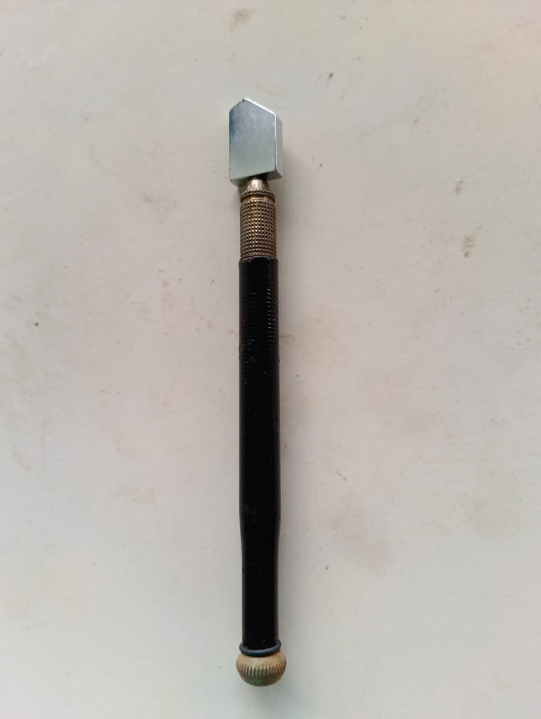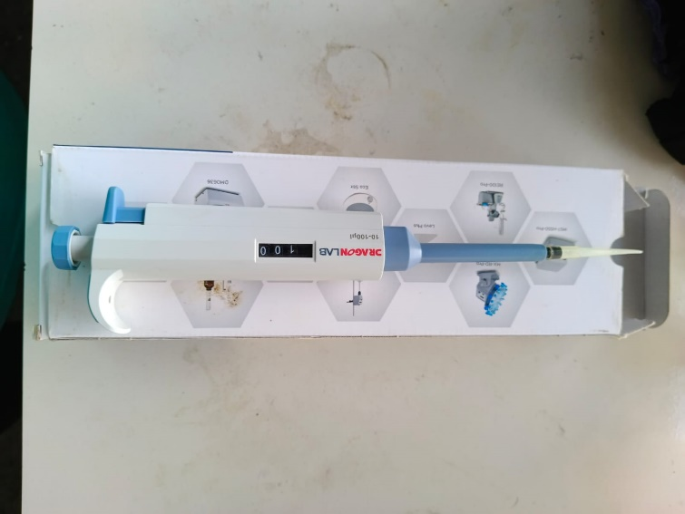

**(d)**

**(c)**

**Figure:** (a) Ultrasonic Cleaner (b) Hot Plate (c) Micro-pipet and (d) Glass Cutter

**Requirements of Raw Material**

|  |  |  |  |
| --- | --- | --- | --- |
| Composition | Raw Materials | Amount(gm) | Total(gm) |
| Pure ZnO film | (CH3COO)2Zn.2H2O | 1.75592 | 1.75592 |
| 1% YZO | (CH3COO)2Zn.2H2O | 1.73836 | 1.77404 |
| Y(NO3)3·6H2O | 0.03568 |
| 3% YZO | (CH3COO)2Zn.2H2O | 1.70324 | 1.81136 |
| Y(NO3)3·6H2O | 0.10812 |
| 5% YZO | (CH3COO)2Zn.2H2O | 1.66812 | 1.84832 |
| Y(NO3)3·6H2O | 0.18020 |

ZAD=0.4M

ZAD and MEA molar ratio= 1:1

**Solution Preparation**

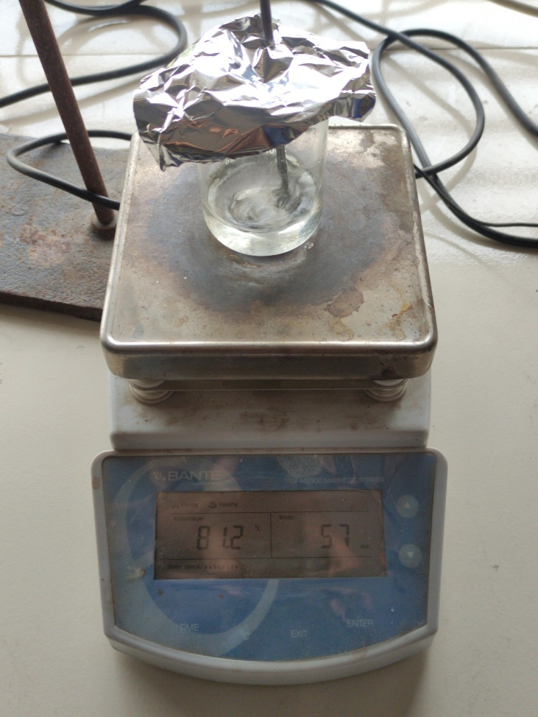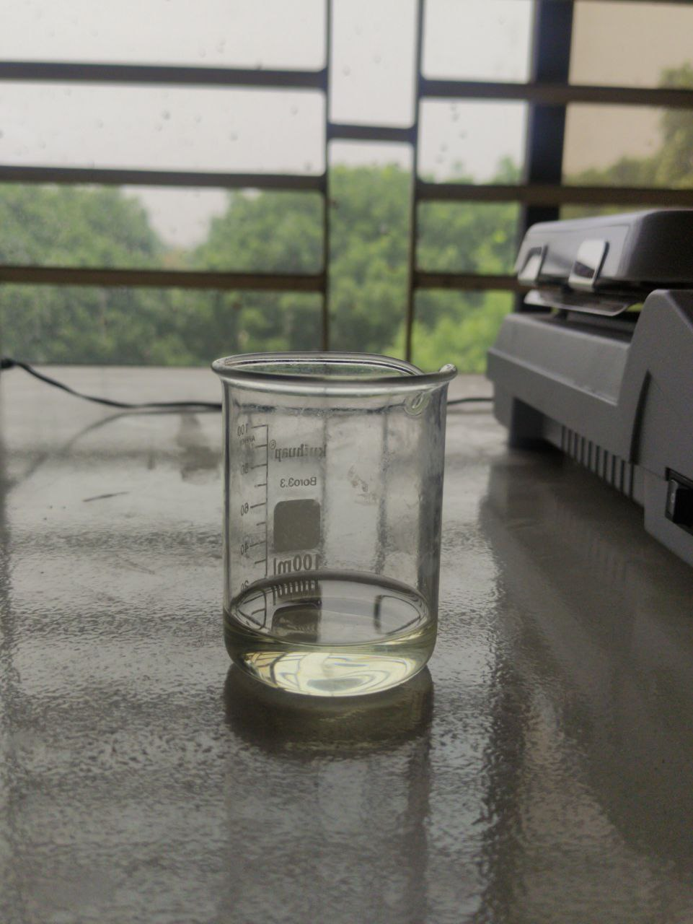

**(b)**

**(a)**

**Figure 3.5**: (a) Initial Solution (precursor) and

(b) Solution stirring for 1 hour

**Steps in detail:**

**Weighting:**

* Weighting should be as perfect as possible
* Before weighing, spoons should be washed with de-ionized and acetone
* The powders should be weighted just before experiment, otherwise contamination can be occurred.

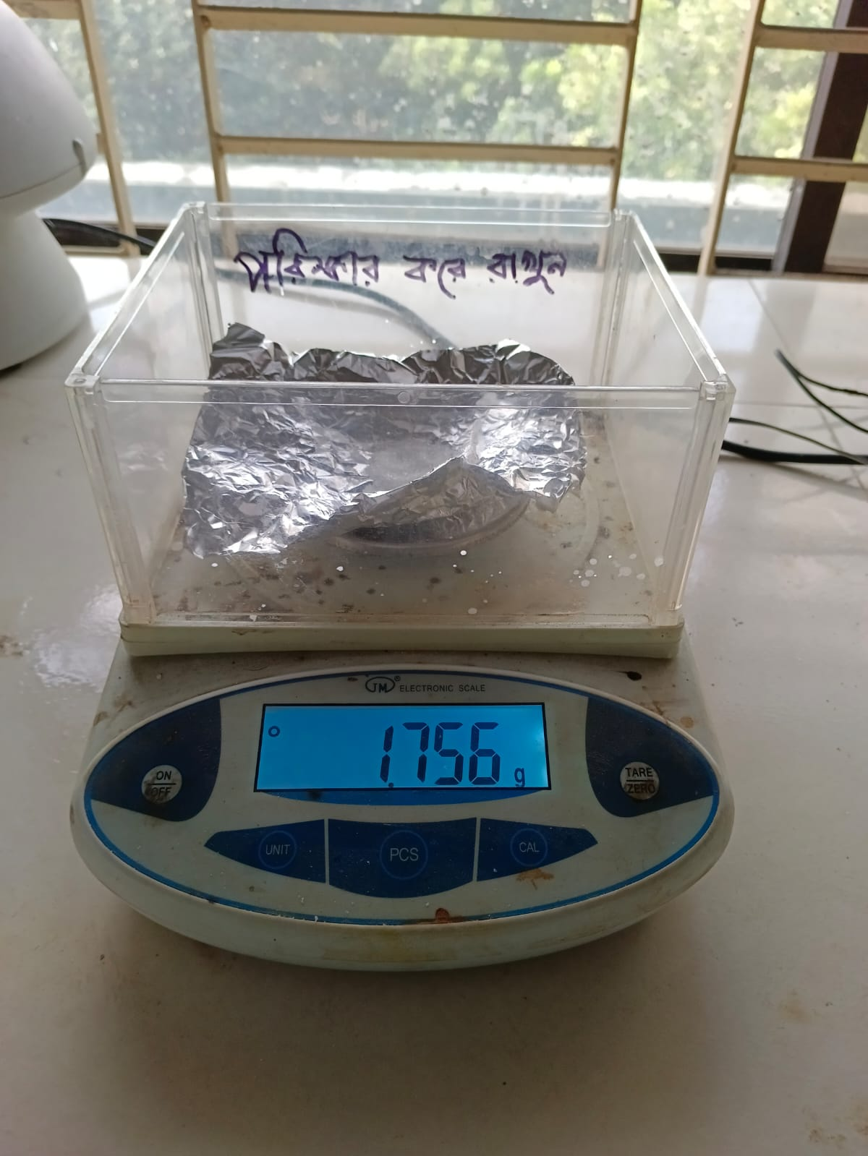

**Figure:** Weighting Procedure

**Mixing:**

* At first solvent is added in a washed beaker (Beaker is also washed with de-ionized and acetone)
* Then starting material and doping material are added.
* Finally, stabilizer is added.

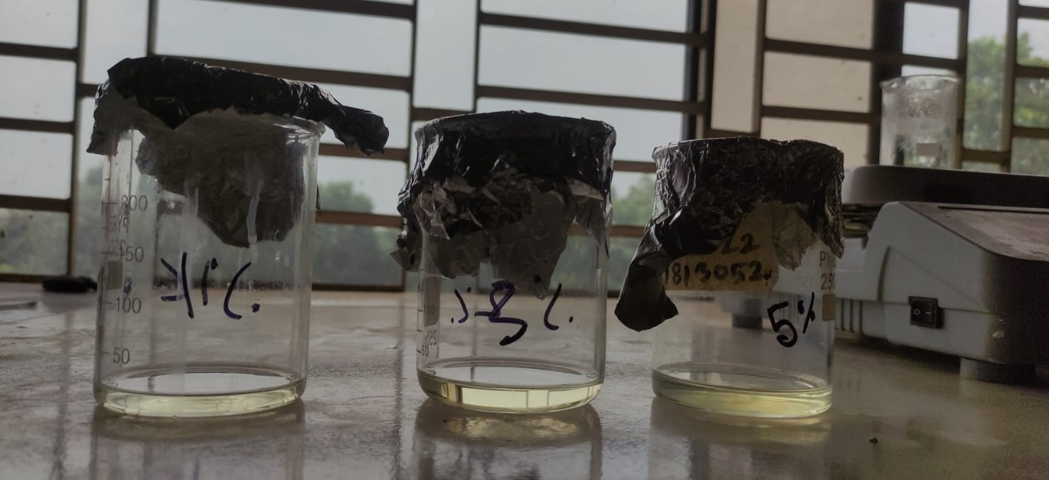

**Figure:** Solution After Mixing (1% YZO, 3% YZO, and 5% YZO)

**Stirring:**

* Stirring is done at 400 rpm at 80° C.
* As our solution quantity is small, we used a small sized magnetic stirrer.
* Temperature control is very important. Thermometer is used for this. When hot plate indicated 115° C, thermometer indicates 80° C.
* After when thermometer indicates 80° C, time counting is started.
* After 1 hour stirring, the solution is covered with aluminum foil and kept for aging for 24 hours.

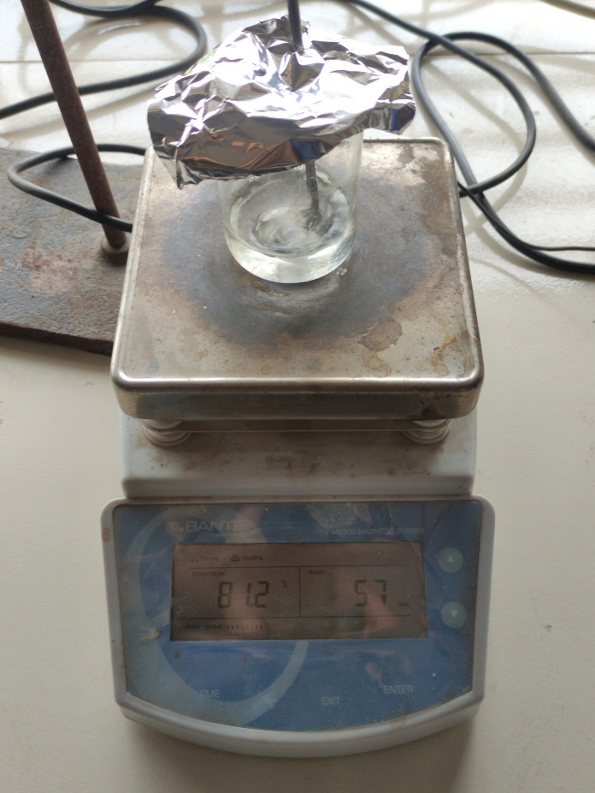

**Figure:** Solution stirring for 1 hour

**Possible chemical reactions**

(CH3COO)2Zn.2H2O + H2O ZnO + CO2 (g) + CH4 (g) + steam (g)

**Glass Preparation**

* Glass is prepared by cleaning with acetone, ethanol, de-ionized water by cotton. Ultra-sonification with de-ionized water, ethanol, acetone.
* At first silica glass is cut in appropriate size by glass cutter.
* Then the glass is brushed with detergents and washed with water.
* Then the glass is ultrasonified with de-ionized water for 5 min.
* After that the glass is ultrasonified with ethanol, acetone and again de-ionized water, each one is for 5 min
* After each drying stage the glass substrate is dried using hotplate.
* Now the glass substrate is ready for coating.
* 60% efficiency of producing uniform film depends on glass cleaning properly.

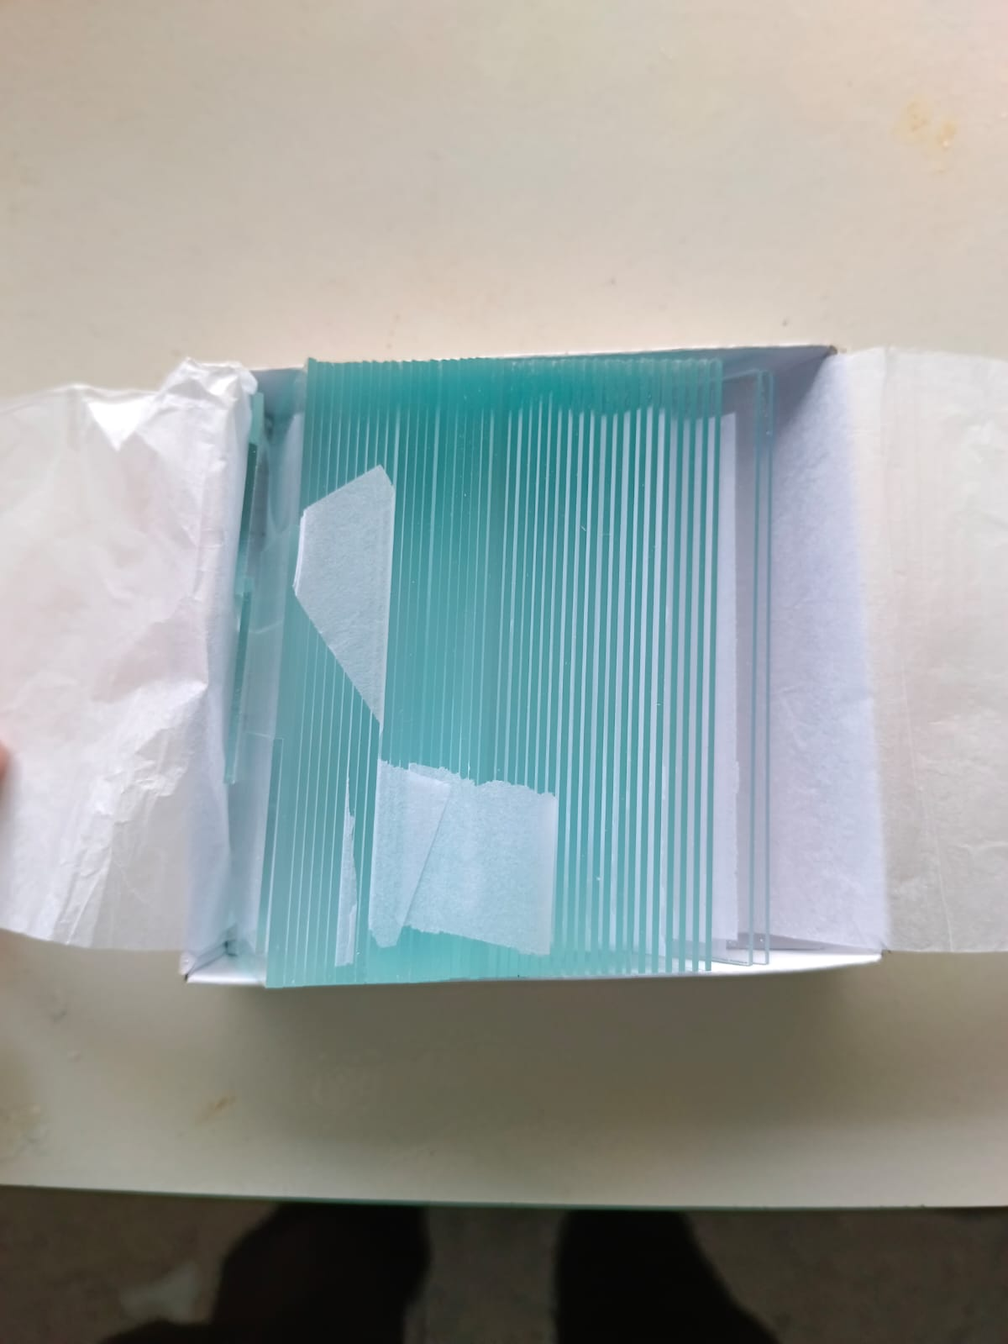

**(b)**

**(a)**



**(c)**

**Figure:** (a) Glass Slide; (b) Glass Slide After Cutting and (c) Dipped in distilled water, ethanol and acetone

**Spin coating**

* At first static coating technique is applied. But unfortunately, film quality was not good. Film was not uniform. Then dynamic spin coating technique is applied. Speed is modified experimentally.
* Solution is given using 1ml pipette. Spin coater speed is modified at1000 rpm for 10 second, then 3000 rpm for 20 sec. At first speed is low because the solution is given. To reduce scattering of the solution. Spin coater should be covered with aluminium foil.
* Glass substrate is kept at the right place. Vacuum on is done by switching.



**Figure:** Spin Coater

* Then on button is pressed and 0.05 ml solution is given on the substrate.
* After 30 seconds rotating would be stopped. Then we have to off vacuum.
* After drying, second layer is given.

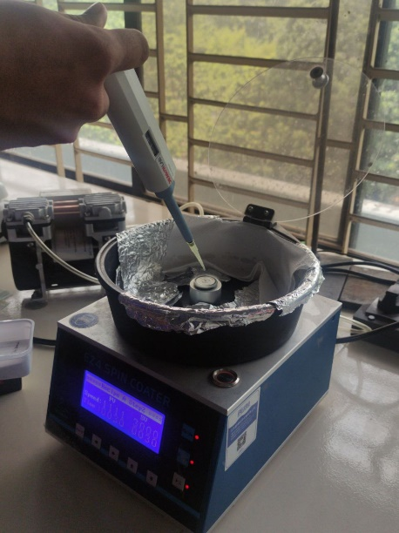

**Figure:** Spin coating process

**Drying**

After spin coating, drying for 5 min at 200 ℃. At first this step was done using furnace. But there is a great chance of contamination with the furnace atmosphere. And it was really uncomfortable. Then we started drying in the hot plate.

* At first hot plate temperature is fixed at 200℃.
* After each coating step the glass substrate is taken to hot plate.
* 5 min is the drying period.
* After drying, the sample is cooled and readied for the 2nd layer.

**Annealing**

* For annealing the thin film Protherm furnace was used. It took little time about 1 hour and 20 minutes to reach 500° C. Then 2 hour holding period and after that furnace cooling.
* Masking tape is used for making a step for measuring thickness with profilometer. But the masking tape was vaporized during high temperature annealing. Thus, film contamination occurred. For recovering that problem,
* we used at first better quality masking tape. After drying stage, the masking tape was removed as it cannot withstand the high temperature of annealing.



Figure 3.12: Annealing graph

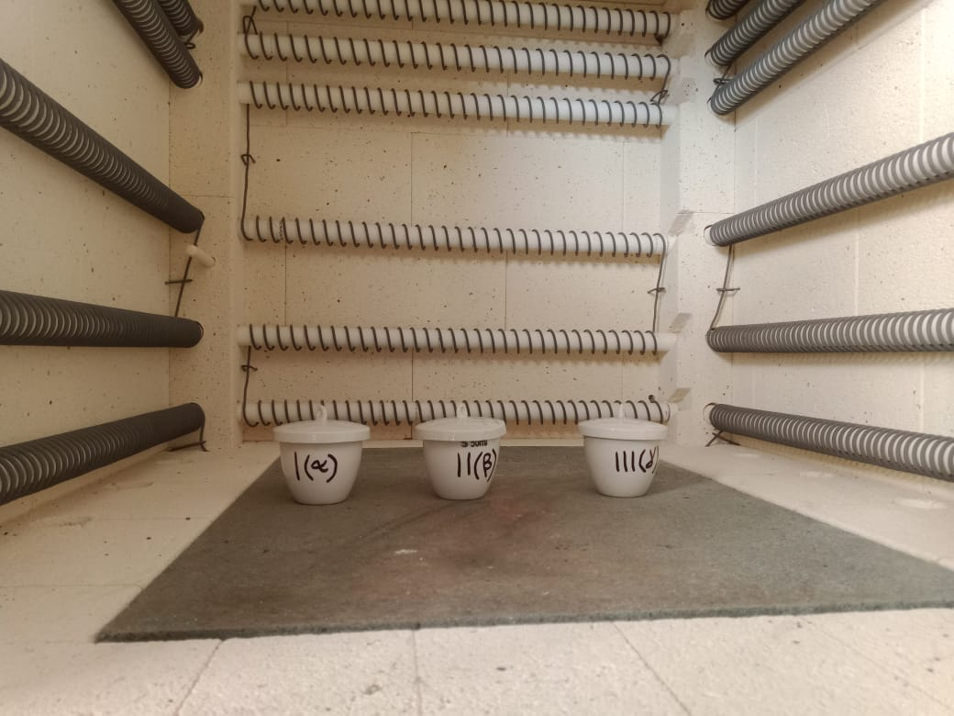

Figure: Placing samples for annealing